Erick Cabrera

ITM 311-02

Lab No. 2

September 13, 2016

Purpose: Build a program that calculates simple interest.

**Source Code:**

// Program to calculate Simple Interest.

// Programmer: Erick Cabrera, File Name: Interest.java

// the packages

import java.text.DecimalFormat;

import javax.swing.JOptionPane;

// the class definition

public class Interest

{

// the global variables are declared

static double earnings = 0, principal = 0, rate = 0, time = 0;

// introduce a DecimalFormat object

static DecimalFormat twoPlace = new DecimalFormat("0.00");

// the method to obtain data

public static void getData()

{

// local variables declared and assigned initial values

String firstNum = "", secondNum = "", thirdNum = "";

// local variables updated via prompt boxes

firstNum = JOptionPane.showInputDialog("Enter the Principal");

secondNum = JOptionPane.showInputDialog("Enter Rate, as a %");

thirdNum = JOptionPane.showInputDialog("Enter Time, in years");

// update the global variables

principal = Double.parseDouble(firstNum);

rate = Double.parseDouble(secondNum);

time = Double.parseDouble(thirdNum);

}

// the main() method

public static void main(String args[])

{

// call the getData() method

getData();

// update a global variable

earnings = principal * rate / 100 * time;

// display the result in a message box

JOptionPane.showMessageDialog(null, "interest earnings: $" +

twoPlace.format(earnings), "Result", JOptionPane.PLAIN_MESSAGE);

System.exit(0);

}

}

**Output:**

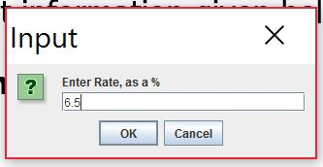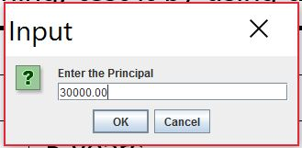

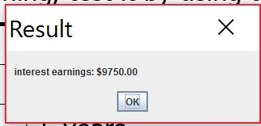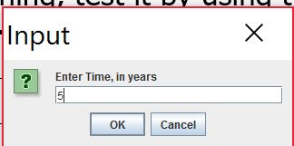

**Excel Sheet:**

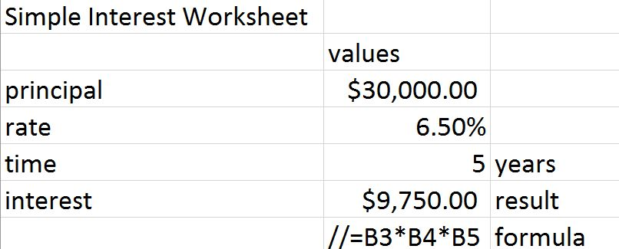

**Modified Source Code:**

// Program to calculate Simple Interest.

// Programmer: Erick Cabrera, File Name: Interest.java

// the packages

import java.text.DecimalFormat;

import javax.swing.JOptionPane;

// the class definition

public class Interest

{

// the global variables are declared

static double earnings = 0, principal = 0, rate = 0, time = 0, total = 0;

// introduce a DecimalFormat object

static DecimalFormat twoPlace = new DecimalFormat("0.00");

// the method to obtain data

public static void getData()

{

// local variables declared and assigned initial values

String firstNum = "", secondNum = "", thirdNum = "";

// local variables updated via prompt boxes

firstNum = JOptionPane.showInputDialog("Enter the Principal");

secondNum = JOptionPane.showInputDialog("Enter Rate, as a %");

thirdNum = JOptionPane.showInputDialog("Enter Time, in years");

// update the global variables

principal = Double.parseDouble(firstNum);

rate = Double.parseDouble(secondNum);

time = Double.parseDouble(thirdNum);

}

// method that calculates accumulated interest earnings

public static void calcAccumulated(){

// calculate interest earnings

earnings = principal * rate / 100 * time;

//calculate accumulated amount

total = earnings + principal;

}

// method that shows accumulated interest earnings

public static void showAccumulated(){

// display the result in a message box

JOptionPane.showMessageDialog(null, "interest earnings: $" +

twoPlace.format(earnings) + "\n" +

"accumulated amount: $" +

twoPlace.format(total),"Result",

JOptionPane.PLAIN_MESSAGE);

}

// the main() method

public static void main(String args[])

{

// call the getData() method

getData();

//call the calcAccumulated() method

calcAccumulated();

// call the showAccumulated() method

showAccumulated();

System.exit(0);

}

}

**Modified Output**

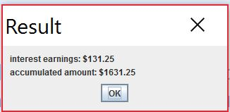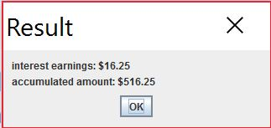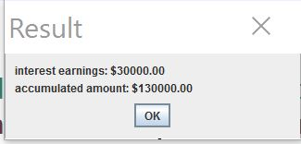A) B) C)

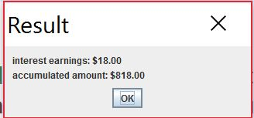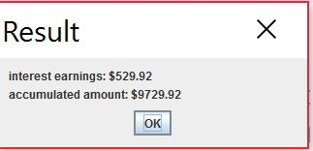D) E)

**Modified Excel Sheet:**

